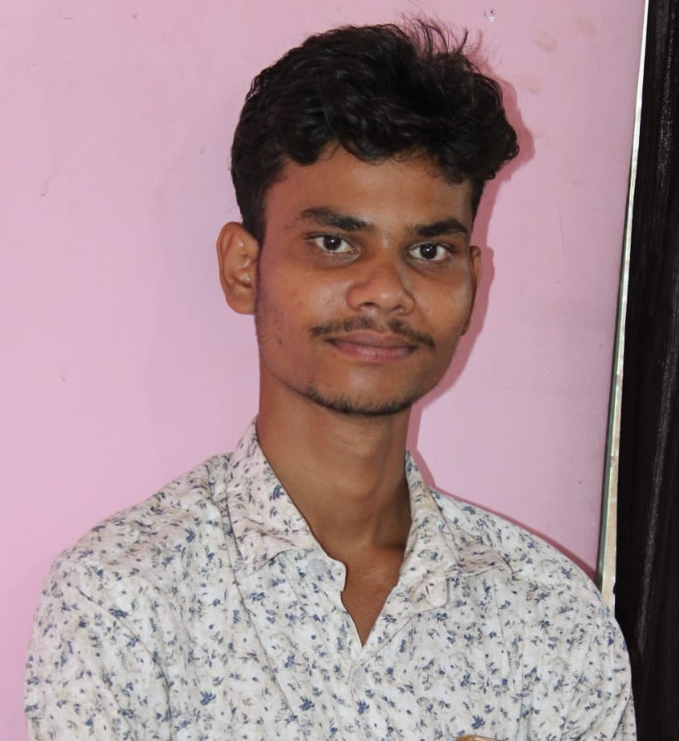 | SHIVAM KUMAR  Dhongra, Jehanabad, Bihar - 804408  Phone: +91 8235230743  Email: shivamshivamkumar26097@gmail.com

PROFESSIONAL SUMMARY
To obtain a challenging and rewarding position in a professional organization where I can utilize my skills, knowledge, and abilities to contribute to the growth and success of the organization. I am looking for a long term and mutually beneficial relationship with an organization that provides opportunities for professional growth, continuous learning, and development. I am willing to take on new responsibilities, learn from every experience, and consistently improve myself through hard work, dedication, and a positive attitude.
EDUCATION
2020 – 2021 | Secondary (10th) | Utkramit M S Ahiyasa,  Jehanabad | 3rd Division  192/500
PROFESSIONAL EXPERIENCE
Site Assistant Duration: Mar 2024 – May 2026
• Assisted in day to day site operations and ensured assigned tasks were completed efficiently and on time.
• Maintained proper handling, storage, and movement of construction materials and equipment at the worksite.
• Followed workplace safety procedures and maintained cleanliness and organization in the assigned work area.
• Coordinated with supervisors and team members to complete daily activities and meet work requirements.
• Demonstrated reliability, discipline, teamwork, and willingness to learn and take on new responsibilities.
SKILLS
• Hardworking, responsible, and disciplined
• Relationship building and customer engagement
• Product knowledge and quick learning ability
• Sales aptitude and target oriented mindset
• Time management, adaptability
DECLARATION
I hereby declared that the above information given by me is true to the best of my Knowledge.

